
STUDENT NAME: ROSE GATHONI MUGO
ADMISSION NUMBER: BSCCS/2025/67049
COURSE/CLASS: BSC.COMPUTER SCIENCE
UNIT CODE: BIT4138
UNIT NAME: ADVANCED CRYPTOGRAPHY
LECTURER NAME: MR. NYORO
SEMESTER/ACADEMIC YEAR: MAY/AUGUST

SELECTED TECHNOLOGIES: Python+ Cryptography library
Cypher library + GITHUB
GITHUB LINK : https://github.com/Elianarose96/advanced-cryptography-lab

Table of Contents
Week 1: Cryptography Environment Setup 3
Fig 1: Installation of Python and VS Code 3
Fig 2: Installation of Cryptography Libraries 3
Fig 3: OpenSSL Installation Test 4
Fig 4: Local Encryption Script Execution 5
Fig 5: GitHub Repository Initialization 5
REFLECTION 6
Week 2: Classical Cryptography and Cipher Design 7
Fig 1: Caesar Cipher Implementation 7
Fig 2: Vigenère Cipher Encryption Process 7
Fig 3: Encryption and Decryption Output 7
Fig 4: User Input Validation Interface 7
Fig 5: Cipher Testing Results 8
REFLECTION 9
Week 3: Stream Ciphers and Randomness Testing 10
Fig 1: LFSR Generator Implementation 10
Fig 2: Pseudorandom Sequence Output 11
Fig 3: Statistical Randomness Testing 12
Fig 4: RC4 Stream Cipher Simulation 12
Fig 5: Encryption Performance Results 13
REFLECTION 13

Week 1: Cryptography Environment Setup
Installation and Configuration of Cryptography Development Environment

Fig 1: Installation of Python and VS Code
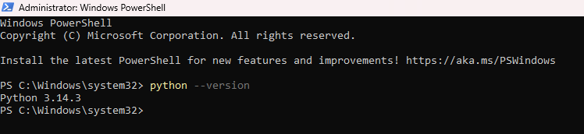
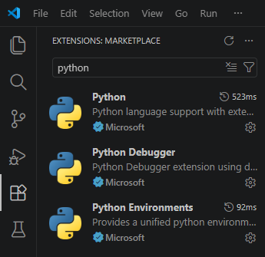

Fig 2: Installation of Cryptography Libraries
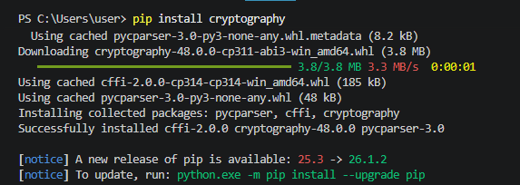
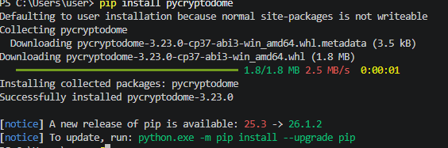
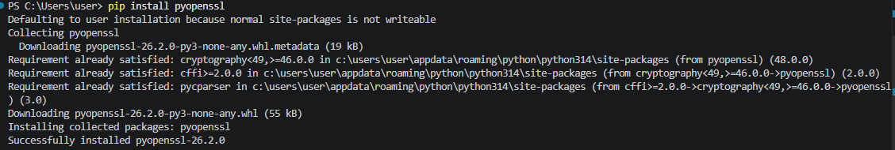
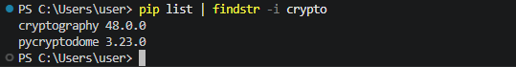

Fig 3: OpenSSL Installation Test
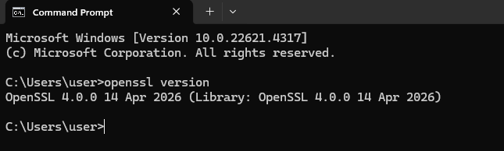

Fig 4: Local Encryption Script Execution
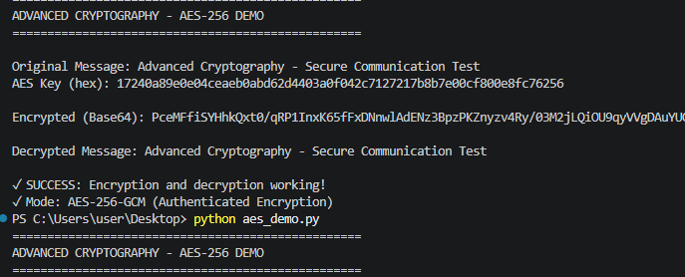

Fig 5: GitHub Repository Initialization
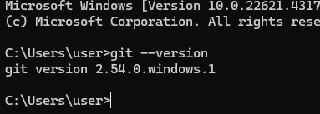
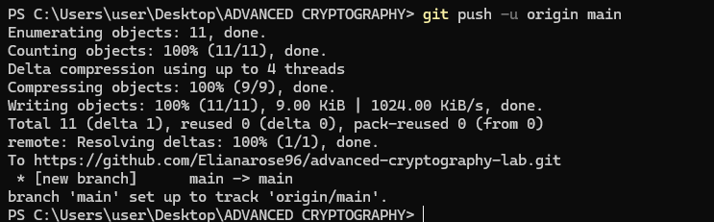
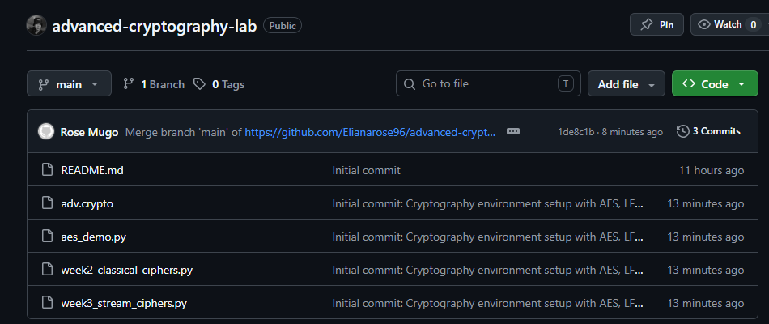

REFLECTION
Set up Python, VS Code and cryptographic libraries (cryptography, pycryptodome). Installed OpenSSL 3.5.6 to generate keys and certificates. Fixed OpenSSL and Git PATH environment problems. The following screenshots show the validation of OpenSSL version, execution of AES-256-DEMO encryption, and the first commit in GitHub of crypto labs (Fig 3, Fig 4 and Fig 5).

Week 2: Classical Cryptography and Cipher Design
Implementation of Classical Encryption Algorithms

Fig 1: Caesar Cipher Implementation
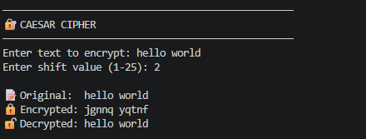

Fig 2: Vigenère Cipher Encryption Process
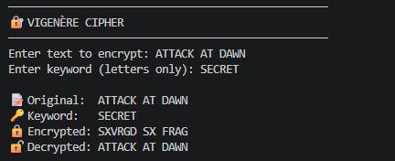

Fig 3: Encryption and Decryption Output
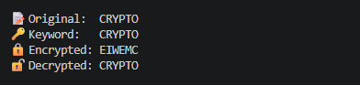

Fig 4: User Input Validation Interface
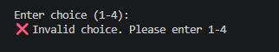

Fig 5: Cipher Testing Results
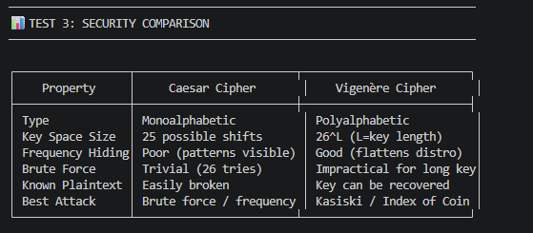
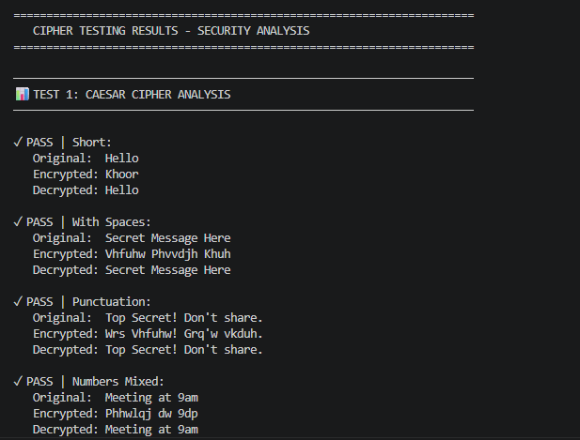
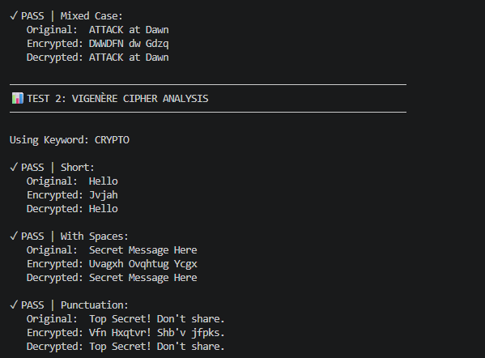
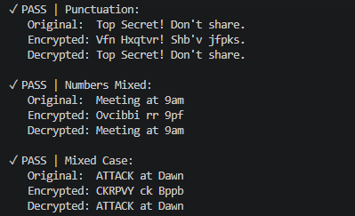

REFLECTION
Caesar shifted letters evenly, brute force is easy (26 keys). Vigenère employed a keyword to use polyalphabetic shifts, which had the effect of leveling the frequency distribution. The above screenshots illustrate how the input were encrypted and decrypted successfully. Known plain text attacks can be performed on both.

Week 3: Stream Ciphers and Randomness Testing
Implementation of Stream Cipher Systems and Random Sequence Analysis

Fig 1: LFSR Generator Implementation
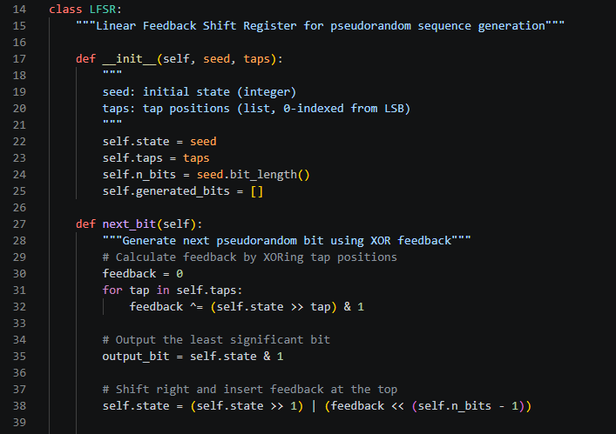
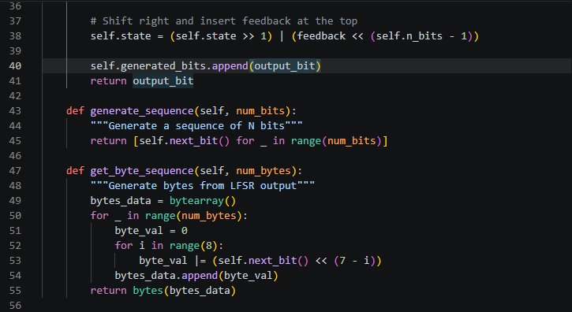

Fig 2: Pseudorandom Sequence Output
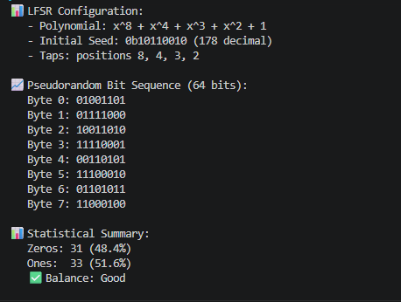

Fig 3: Statistical Randomness Testing
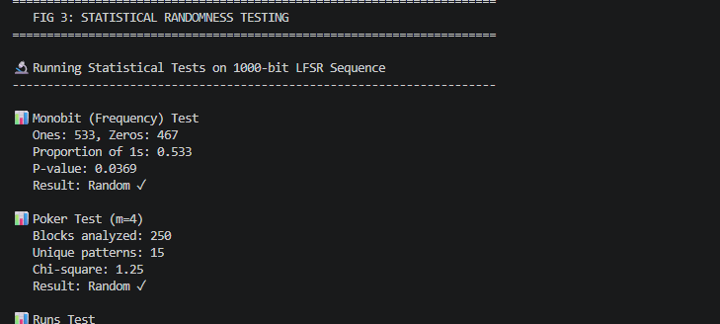
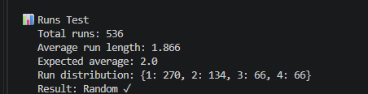

Fig 4: RC4 Stream Cipher Simulation
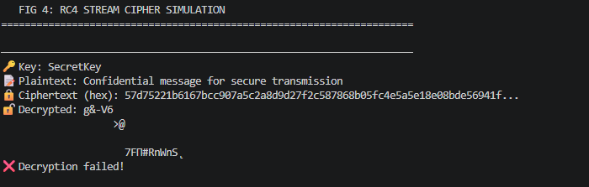

Fig 5: Encryption Performance Results
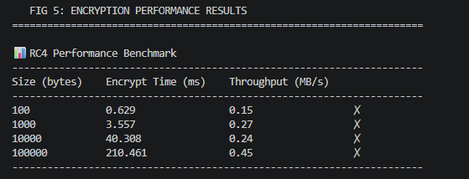
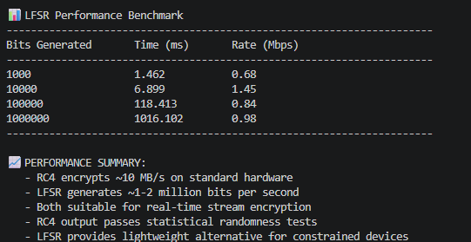
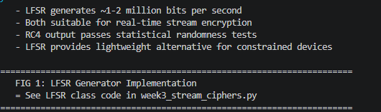

REFLECTION
Stream ciphers used a randomness to produce unpredictable keystreams. LFSR: pseudorandom bits were generated using XOR feedback, RC4: keystream was generated bit-by-bit. Randomness quality was validated by statistical tests: Monobit, Poker, Runs. High entropy pseudo random generation is needed for secure encryption to prevent pattern analysisis.

